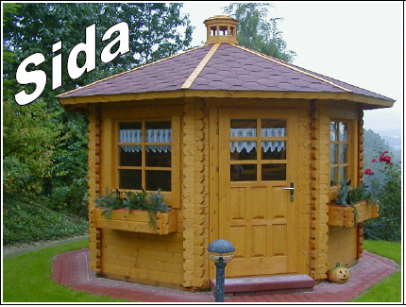
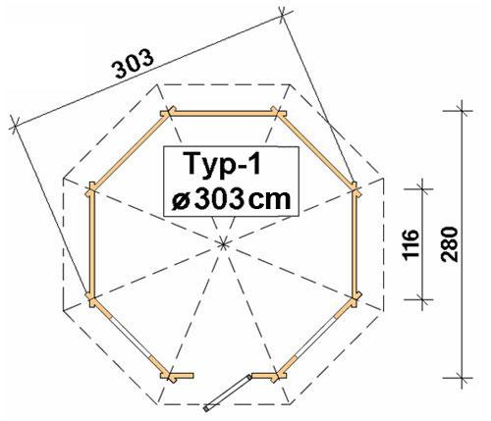
Sida - Door 1/2 glazed and 2 windows
Roof projection: 0.30 m

Consisting of:

Walls: 45 mm double tongue and groove block planks.
Floor: 20 mm tongue and groove with impregnated basic frame.
Roof: 20 mm roof sections.
Doors: 1 glued cartridge door with seal.
Window: 2 Double-Glazed tilt ‘n’ turn windows with seal and rungs.

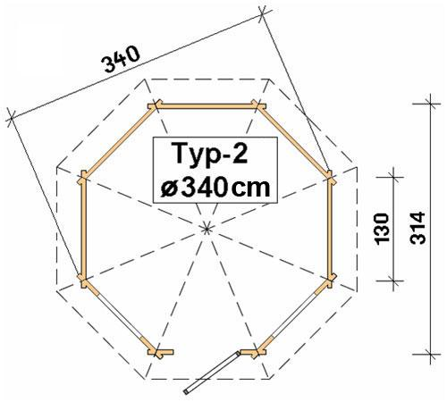

Typ1: 1 door 70/193 and 2 windows 70/94 £2,250
1 additional window 70/94 + £120

Typ2: 1 door 90/193 and 2 windows 90/94 £2,500
1 additional window 90/94 + £130

Typ3: 1 door 90/193 and 2 windows 100/94 £3,300
1 additional window 100/94 + £140

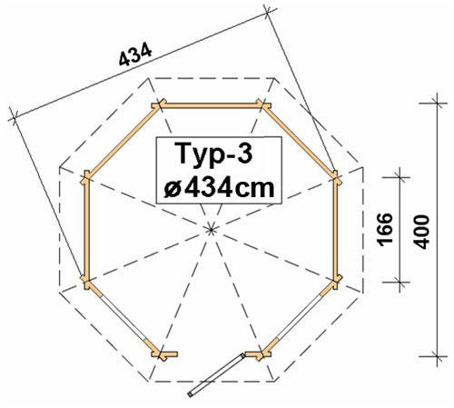

Optional Extras:
Typ1 Typ2 Typ3
Furniture: £470 £505 £580
(7 benches, 1 table)
Roof Shingles: £160 £180 £245

